
JAVA PROGRAMMING

LAB Exercise Unit 2

Submitted by:
Faustena S
(2548313)
2 MDS A

Faculty:
Dr. Heamenth K S

Submitted on 16 Feb. 26

Department of Computer Science and Statistics
Christ (Deemed To Be University),
Yeswanthpur, Bangalore

- Write a Java program to find the largest of three numbers using if-else.

import java.util.Scanner;

public class u2l1 {
public static void main(String[] args) {
Scanner input = new Scanner(System.in);

System.out.print("Enter first number: ");
int a = input.nextInt();

System.out.print("Enter second number: ");
int b = input.nextInt();

System.out.print("Enter third number: ");
int c = input.nextInt();

System.out.println("\nYou entered: " + a + ", " + b + ", " + c);

if (a > b && a > c) {
System.out.println("Largest is: " + a);
}
else if (b > c) {
System.out.println("Largest is: " + b);
}
else {
System.out.println("Largest is: " + c);
}

input.close();
}
}

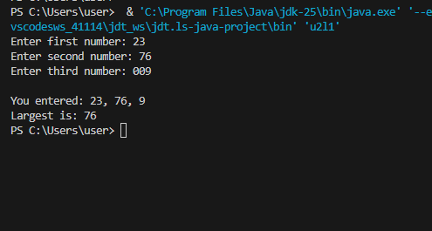
- Implement a calculator using switch-case.

import java.util.Scanner;

public class u2l2 {
public static void main(String[] args) {
Scanner input = new Scanner(System.in);

System.out.print("Enter first number: ");
double num1 = input.nextDouble();

System.out.print("Enter second number: ");
double num2 = input.nextDouble();

System.out.print("Enter operator (+, -, *, /): ");
char op = input.next().charAt(0);

switch (op) {
case '+':
System.out.println(num1 + " + " + num2 + " = " + (num1 + num2));
break;

case '-':
System.out.println(num1 + " - " + num2 + " = " + (num1 - num2));
break;

case '*':
System.out.println(num1 + " * " + num2 + " = " + (num1 * num2));
break;

case '/':
if (num2 != 0) {
System.out.println(num1 + " / " + num2 + " = " + (num1 / num2));
} else {
System.out.println("Error: Cannot divide by zero!");
}
break;

default:
System.out.println("Error: Invalid operator!");
System.out.println("Please use +, -, *, or /");
}

input.close();
}
}

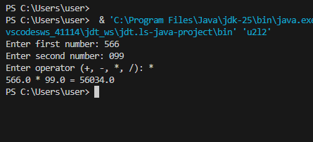

- Write a program to print patterns using nested loops.
- import java.util.Scanner;

- public class u2l3 {
- public static void main(String[] args) {
- Scanner input = new Scanner(System.in);

- System.out.print("Enter number of rows: ");
- int rows = input.nextInt();

- System.out.println("\nPattern 1: Triangle");
- for (int i = 1; i <= rows; i++) {
- for (int j = 1; j <= i; j++) {
- System.out.print("* ");
- }
- System.out.println();
- }

- System.out.println();

- System.out.println("Pattern 2: Reverse Triangle");
- for (int i = rows; i >= 1; i--) {
- for (int j = 1; j <= i; j++) {
- System.out.print("* ");
- }
- System.out.println();
- }

- System.out.println();

- System.out.println("Pattern 3: Number Pattern");
- for (int i = 1; i <= rows; i++) {
- for (int j = 1; j <= i; j++) {
- System.out.print(j + " ");
- }
- System.out.println();
- }

- input.close();
- }
- }

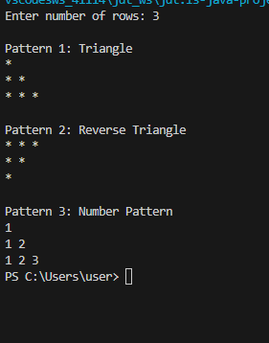
4. Write a program to reverse a number using loops.
import java.util.Scanner;

public class u2l4 {
public static void main(String[] args) {
Scanner input = new Scanner(System.in);

System.out.print("Enter a number: ");
int num = input.nextInt();
int original = num;

int reversed = 0;

while (num != 0) {
int lastDigit = num % 10;
reversed = reversed * 10 + lastDigit;
num = num / 10;
}

System.out.println("\nOriginal number: " + original);
System.out.println("Reversed number: " + reversed);

input.close();
}
}
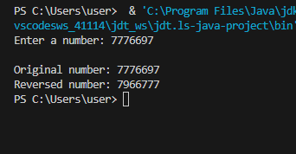
5. Implement a program to check for prime numbers.
import java.util.Scanner;

public class u2l5 {
public static void main(String[] args) {
Scanner input = new Scanner(System.in);

System.out.print("Enter a number: ");
int num = input.nextInt();

boolean isPrime = true;

if (num <= 1) {
isPrime = false;
} else if (num == 2) {
isPrime = true;
} else {

for (int i = 2; i < num; i++) {
if (num % i == 0) {
isPrime = false;
System.out.println(num + " is divisible by " + i);
break;
}
}
}

System.out.println();
if (isPrime) {
System.out.println(num + " is a PRIME number");
} else {
System.out.println(num + " is NOT a prime number");
}

input.close();
}
}

